

***PRIYDARSHANI COLLEGE OF ENGINEERING***

***DEPARTMENT NAME:- ELECTRONIC AND COMMUNICATION***

***ACTIVITY REPORT***

Activity Topic:- Video Lecture On File Management System

*Subject Name:-Operating System*

*Activity Date:-11/11/2022*

*Submitted By :-*

*Ms. Vipashyana Jangale*

*Guided By:-*

*Dr. prof. Ranjeet Bobate*

*File-System Structure :*

>File Structure

>Logical Storage Unit

>Collection Of Related Information

>File System Organized Into Layers

>File System Resides On Secondary Storage(Disks)

>Provides Efficient And Convenient Access To Disk By Allowing Data To Be Stored, Located Retrieved Easily

>File Control Block Storage Structure Consisting Of Information About A File

>Device Driver Controls The Physical Device

**File System Implementation :**

>Boot Control Block Contains Info Needed By System To Boot OS From That Volume

>Volume Control Block Contains Volume Details

>Directory Structure Organizes The Files

>Per-File File Control Block(FCB) Contains Many Details About The File

**Virtual File System :**

>Virtual File Systems(VFS) Provide An Object Oriented Way Of Implementing File System

>VFS Allows The Same System Call Interface(The API) To Be Used For Different Types Of File System

**A Typical File Control Block**

File Permissions

File Dates(Create, Access, Write

File Owner, Group, ACL

File Size

File Data Blocks Or Pointers To File Data Blocks

**Schematic View Of virtual File System**

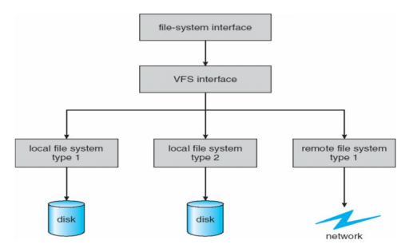

**Directory Implementation :-**

 *Linear list of the filename’s with ponter to the data blocks.*

. *Simple to program*

. *Time consuming to execute*

 *Hash Table :-. Linear list with hash data structure.*

. *Decrease directory search time*

. *Collisions - Situations where two files names hash to the some locations.*

. *Fixed size*

**Activity Pictures :-**

